**IMPORTANT**

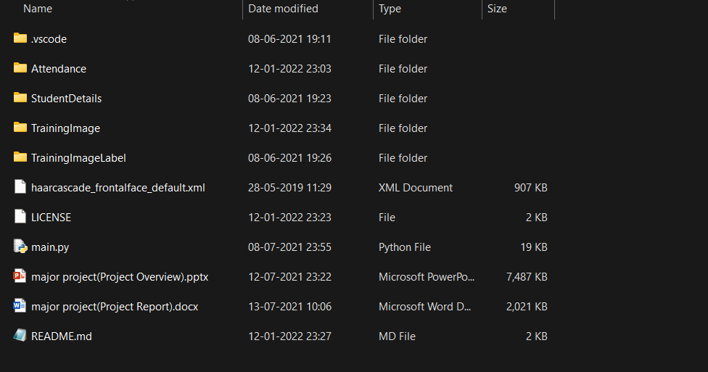

**Few folders such as Attendance, StudentDetails, Training Image, TrainingImageLabel will be created automatically after running the program but if it doesn’t get created automatically then make creates these folders.  
refer to the above screen shot.**